HTML color

**Table of content**

* What is HTML color?
* How to add color in HTML document?
* Different types of color style use in HTML

**What is HTML color?**

HTML color is user for providing different color to your website may be use for providing background color, text color, border color and many more. HTML color consist of predefine color value and name. HTML language supports total 140 color codes which is having separate value for identification.

**Syntax-**

<html start tag style= “color: value;”>Your text</html end tag>

**Example-**

<!DOCTYPE html>

<html>

  <head>

    <title>background color</title>

  </head>

  <body>

    <h2 style="background-color: rgba(248, 82, 138, 0.356)">

      GEEKY4U.com(learn with passion)

    </h2>

    <h3 style="color: rgb(3, 82, 65)">GEEKY4U.com(learn with passion)</h3>

    <p style="background-color: rgb(228, 215, 99)">

      Geeky4u.com (Learn with Passion). This is a best platform where we are

      providing best study material, best content so that it is easy for you to

      learn everything and no one will stop you to become a master in

      programming language

    </p>

    <h2 style="border: 2px solid rgba(56, 114, 221, 0.644)">THANK YOU</h2>

  </body>

</html>

**Output-**



**How to add color in HTML document?**

**HTML language allow you to add different background as well as text and border color into your document so that your text will look more attractive. If you want to add color in HTML document then you need to add style tag in the HTML start tag with color followed by color value or color name.**

**Syntax-**

<html start tag style= “color: value;”>Your text</html end tag>

**Example-**

<!DOCTYPE html>

<html>

  <head>

    <title>background color</title>

  </head>

  <body>

    <h2 align="center" style= "background-color: rgba(112, 211, 250, 0.918)">

      GEEKY4U.com(learn with passion)

    </h2>

    <h3 style="color: rgb(3, 82, 65)">GEEKY4U.com(learn with passion)</h3>

    <p style="background-color: rgb(228, 215, 99)">

      Geeky4u.com (Learn with Passion). This is a best platform where we are

      providing best study material, best content so that it is easy for you to

      learn everything and no one will stop you to become a master in

      programming language

    </p>

    <h2 align="center"style="border: 2px solid rgba(56, 114, 221, 0.644)">THANK YOU</h2>

  </body>

</html>

**Output-**

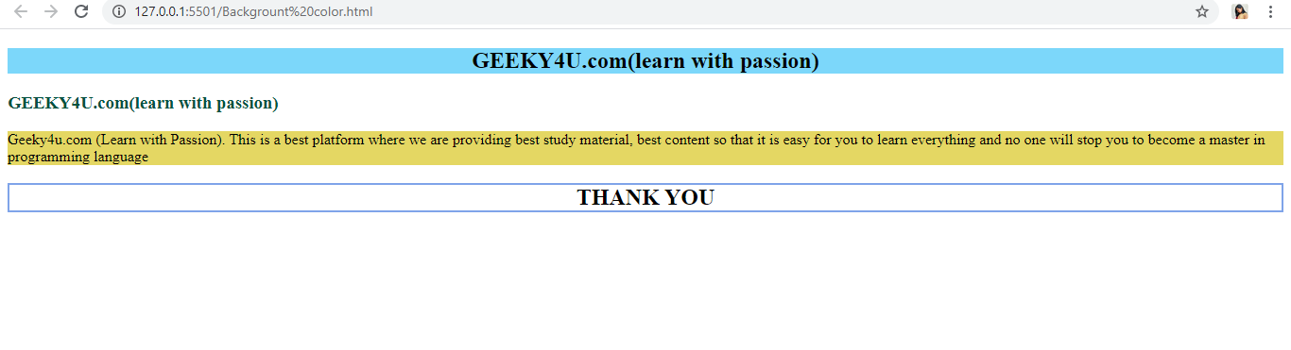

**Different types of color style use in HTML**

**Background color-**

Background color is user for providing background color to your text.

**Syntax-**

<html start tag style= “Background-color: value;”>Your text</html end tag>

**Example-**

<!DOCTYPE html>

<html>

  <head>

    <title>background color</title>

  </head>

  <body>

    <h2 style="background-color: rgba(65, 231, 231, 0.356)">

      GEEKY4U.com(learn with passion)

    </h2>

    <p style="background-color: rgb(226, 253, 107)">

      Geeky4u.com (Learn with Passion). This is a best platform where we are

      providing best study material, best content so that it is easy for you to

      learn everything and no one will stop you to become a master in

      programming language

    </p>

  </body>

</html>

**Output-**



**Text color-**

If you want to give color to your text then text color is used. For adding text color you need to add style tag into the HTML start tag along with color with their value and name .

**Syntax-**

<html start tag style= “color: value;”>Your text</html end tag>

**Example-**

<!DOCTYPE html>

<html>

  <head>

    <title>text color</title>

  </head>

  <body>

    <h3 style="color: rgb(45, 197, 164)">GEEKY4U.com(learn with passion)</h3>

    <h3 style="color: rgb(85, 107, 7)">GEEKY4U.com(learn with passion)</h3>

    <h3 style="color: rgb(204, 48, 134)">GEEKY4U.com(learn with passion)</h3>

  </body>

</html>

**Output-**

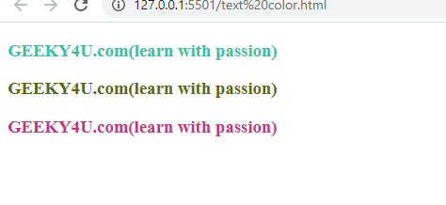

**Border color-**

Border tag use for inserting border to your text.

**Syntax-**

<html start tag style= “border:px value;”>Your text</html end tag>

**Example-**

<!DOCTYPE html>

<html>

  <head>

    <title>border color</title>

  </head>

  <body>

    <h2 style="border:2px solid rgba(56, 114, 221, 0.644); ">GEEKY4U.com(learn with passion)</h2>

    <h2 style="border:2px solid rgba(107, 7, 57, 0.904); ">GEEKY4U.com(learn with passion)</h2>

  </body>

</html>

**Output-**

